
PROJECT REPORT
ROBOTIC NAVIGATION SYESTEM

March 25, 2026
VIT BHOPAL UNIVERSITY
KOTHRI KALAN MADHYAPRADESH

INDEX OF THE PROJECT REPORT
1)TITLE
2) INTRODUCTION
3) MOTIVATION OF THE PROJECT
4) PROBLEM STATEMENT
5)OBJECTIVE OF THE PROJECT
6) EXISTING METHODS
7) PROS AND CONS OF THE STATED METHODS
8)HARDWARE AND SOFTWARE REQUIREMENTS
9) METHODOLOGY AND GOAL
10) FUNCTIONAL MODULES DESIGN AND ANALYSIS
11)ALGORITHM DEVELOPMENT
12) SOFTWARE ARCHITECTURAL DIAGRAM
13)CODING
14) OUTPUT
15) KEY IMPLEMENTATION
16) SIGNIFICANT PROJECT OUTCOMES
17)TESTING AND REFINEMENT
18)REAL WORLD APPLICATIONS
19) CONTRIBUTION OF THE PROJECT
20)LIMITATIONS OF THE SYESTEM
21) CONCLUSIONS
22) FUTUTRE ENHANCEMENT
23) REFERENCES

PROJECT REPORT

TITLE OF THE PROJECT : ROBOTIC NAVIGATION SYSTEM
STUDENT NAME : MANALI SONI
REGISTRATION NO: 25BCE10898
COURSE NAME : FUNDAMENTALS IN AI-ML
COURSE CODE : CSA2001
PROFESSOR : DR. M K JAYANTHI MAM

- TITLE : The title of my project is robotic navigation system using BFS ( breadth first search ), DFS( depth first search ), UCS (uniform cost search ) and heuristic search .

- INTRODUCTION : Robotic navigation occupies a special area in artificial intelligence . In this project a robot moves from one location to another by avoiding barriers . This mainly uses BFS,DFS ,UCS types of search algorithm .This will help the robot to find the best possible path in a environment like a map.

- MOTIVATION OF THE PROJECT : Nowadays robots are widely used n industries ,education and healthcare systems . we need to navigate efficiently because this will save the time energy and various resources . This project will compare the different AI search algorithm for ideal pathfinding .

- PROBLEM STATEMENT : The main problem is to design a robot system which can find the shortest and the most efficient path from start node to the end node by using different search algorithms.

- OBJECTIVE OF THE PROJECT :

- To implement BFS , DFS, UCS , A*algorithms .
- To compare the performance .
- To find shortest and optimal path .
- To show robot movement in a grid environment .

6) EXISTING METHODS : Traditional navigation includes only simple problem solutions it does not contain the solution of complex problem . New technologies include the modern AI approaches like searching algorithm and decision making .

7) PROS AND CONS OF THE STATED METHODS :
BFS :
- Finds shortest path
- High memory usage is there .

DFS :
- First go deeply into the solution and then if it is wrong then come back and try again
- Basically its backtracking .
- May not find the shortest path
UCS :
- It is uniform cost search
- It suggests the cheapest and the optimal solution of the path.
- It needs good heuristic search

8) HARDWARE AND SOFTWARE REQUIREMENTS :
HARDWARE :
- Laptop
- minimum 4GB RAM
SOFTWARE :
- Python
- Google collab
- Libraries : NumPy , Matplotlib

9) METHODOLOGY AND GOAL : This project uses a grid based environment on which the robot moves step by step. The main goal of this project is to compare the result of path length ,time taken and efficiency .

10) FUNCTIONAL MODULE DESIGN AND ANALYSIS :
- Input module
- Search algorithm module
- Pathfinding module
- Visualization module
- Output modules

11) ALGORITHM DEVELOPMENT :
1) Start
2) Define grid with barriers
3) Apply search algorithm
4) Track the visited nodes
5) Generate the path developed
6) Output result
7) Stop

12) SOFTWARE ARCHITECTURAL DIAGRAM :
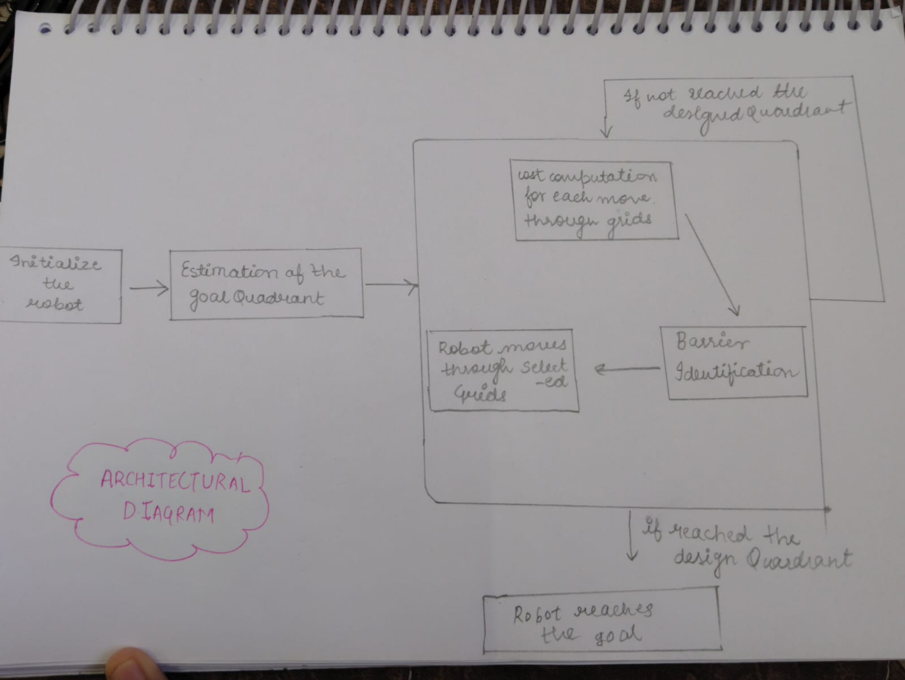

13) CODING : This project uses python language for each algorithm . It explores nodes uniquely and returns the final path .
from collections import deque
import heapq

# حركة directions (up, down, left, right)
directions = [(-1,0), (1,0), (0,-1), (0,1)]

# Check valid cell
def is_valid(grid, x, y, visited):
return (0 <= x < len(grid) and
0 <= y < len(grid[0]) and
grid[x][y] == 0 and
(x, y) not in visited)

# ---------------- BFS ----------------
def bfs(grid, start, goal):
queue = deque([(start, [start])])
visited = set()

while queue:
(x, y), path = queue.popleft()

if (x, y) == goal:
return path

visited.add((x, y))

for dx, dy in directions:
nx, ny = x + dx, y + dy
if is_valid(grid, nx, ny, visited):
queue.append(((nx, ny), path + [(nx, ny)]))

return None

# ---------------- DFS ----------------
def dfs(grid, start, goal):
stack = [(start, [start])]
visited = set()

while stack:
(x, y), path = stack.pop()

if (x, y) == goal:
return path

if (x, y) in visited:
continue

visited.add((x, y))

for dx, dy in directions:
nx, ny = x + dx, y + dy
if is_valid(grid, nx, ny, visited):
stack.append(((nx, ny), path + [(nx, ny)]))

return None

# ---------------- UCS ----------------
def ucs(grid, start, goal):
pq = []
heapq.heappush(pq, (0, start, [start]))
visited = set()

while pq:
cost, (x, y), path = heapq.heappop(pq)

if (x, y) == goal:
return path, cost

if (x, y) in visited:
continue

visited.add((x, y))

for dx, dy in directions:
nx, ny = x + dx, y + dy
if is_valid(grid, nx, ny, visited):
heapq.heappush(pq, (cost + 1, (nx, ny), path + [(nx, ny)]))

return None

# ---------------- A* ----------------
def heuristic(a, b):
return abs(a[0] - b[0]) + abs(a[1] - b[1])

def astar(grid, start, goal):
pq = []
heapq.heappush(pq, (0, 0, start, [start]))
visited = set()

while pq:
f, g, (x, y), path = heapq.heappop(pq)

if (x, y) == goal:
return path, g

if (x, y) in visited:
continue

visited.add((x, y))

for dx, dy in directions:
nx, ny = x + dx, y + dy
if is_valid(grid, nx, ny, visited):
new_g = g + 1
new_f = new_g + heuristic((nx, ny), goal)
heapq.heappush(pq, (new_f, new_g, (nx, ny), path + [(nx, ny)]))

return None

# ---------------- MAIN ----------------
if __name__ == "__main__":
grid = [
[0, 0, 0, 1, 0],
[1, 1, 0, 1, 0],
[0, 0, 0, 0, 0],
[0, 1, 1, 1, 1],
[0, 0, 0, 0, 0]
]

start = (0, 0)
goal = (4, 4)

print("===== ROBOT NAVIGATION RESULTS =====\n")

print("BFS Path:")
print(bfs(grid, start, goal))

print("\nDFS Path:")
print(dfs(grid, start, goal))

print("\nUCS Path:")
result_ucs = ucs(grid, start, goal)
print(result_ucs)

print("\nA* Path:")
result_astar = astar(grid, start, goal)
print(result_astar)

14) OUTPUT : The output compare the path distance ,time taken and efficiency of different search algorithms .
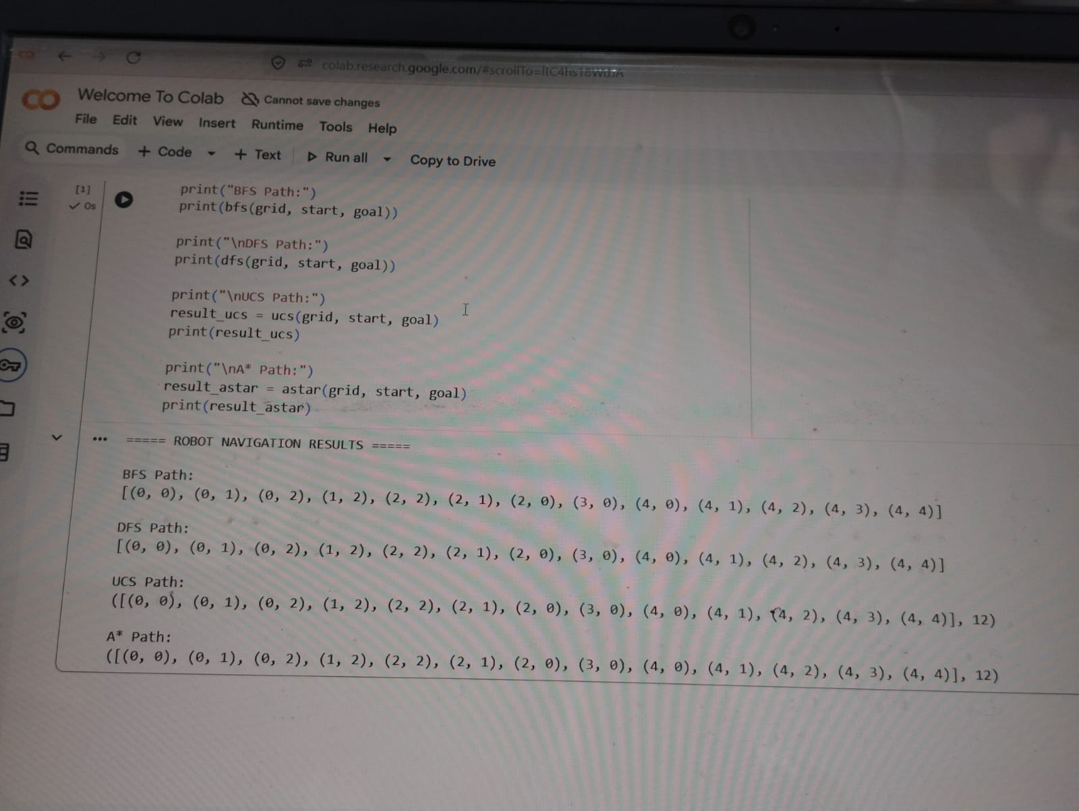

15) KEY IMPLEMENTATION :
- Grid based system
- Implementation of search algorithms
- Comparision of efficiency
- Results visuals

16) SIGNIFICANT PROJECT OUTCOMES :
- Understanding of search algorithms
- Improved skills in problem solving
- Knowledge about navigation system

17) TESTING AND REFINEMENT : This system is tested with different parameters like Barries and gird sizes . It can be improved by optimizing code and smart search .

18) REAL WORLD APPLICATIONS :
- Self driving cars
- Delivery system
- Game ai navigation

19) CONTRIBUTION OF THE PROJECT : This project helps in better understanding ai tools . and also how ai is used in real world applications and providing a base for robotic navigation system .

20) LIMITATIONS OF THE SYSTEM :
- Works in static environment
- It depends on grid size
- Heuristic accuracy is affected .

21) CONCLUSIONS : It demonstrates the different search algorithms ,and A* perform best in all the available cases due to its efficiency and optimality .
22) FUTUTRE ENHANCEMENT:
- Uses real robotic hardware
- Implement ML for better learning
- 3d environment navigation
- Dynamic barriers

23) REFERENCES :
- Artificial intelligence a modern approach
- Python documentation
- Research papers on finding algorithms .

